zero discrimination day

Zero Discrimination Day 2024: Here's all you need to know about the date, history, significance and theme of Zero Discrimination Day this year

Kofi Annan once said, “We may have different religions, different languages, coloured skin, but we all belong to one human race” and we cannot agree more as we try to imbibe this motto and use [love](https://www.hindustantimes.com/topic/love) as a cure or counter against the rising hatred and [discrimination](https://www.hindustantimes.com/topic/discrimination) in today's time, before it becomes a disease. Zero Discrimination Day is observed annually to promote [inclusion](https://www.hindustantimes.com/topic/inclusion), equality, [peace](https://www.hindustantimes.com/topic/peace) and create awareness among people about their rights to live a peaceful life, address discrimination and its impact on individuals, communities and societies.

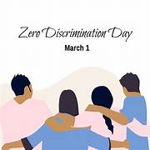

**Date:**

Zero Discrimination Day is observed every year on March 1.

Hindustan Times - your fastest source for breaking news! [Read now.](https://www.hindustantimes.com/india-news)

**History:**

The day was first celebrated on March 1, 2014 after UNAIDS, a joint United Nations program on Human Immunodeficiency Virus (HIV) and Acquired Immune Deficiency Syndrome (AIDS), launched its Zero Discrimination Campaign on 'World AIDS Day' in December 2013. The then-Executive Director of UNAIDS Michel Sidibé launched the day in 2014 with a major event in Beijing.

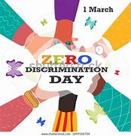

## Significance:

Zero Discrimination Day is celebrated to promote equality, inclusion, and tolerance across the globe. Discrimination in any form deeply impacts an individual. It also violates human rights, and creates barriers to access education, healthcare, and job opportunities, which eventually perpetuates poverty and inequality.

According to the UNAIDS, “Criminalisation drives discrimination and structural inequalities. It robs people of the prospect of healthy and fulfilling lives and it holds back the end of AIDS. We must end criminalisation to save lives.

We can end AIDS – if everyone’s rights are protected. The world has made great progress towards the goal of ending AIDS as a public health threat by 2030. That progress has been powered by progress in protecting human rights. But laws, policies and practices that punish, discriminate against and stigmatize women and girls, key populations, and other marginalized communities violate human rights and obstruct access to HIV prevention, testing, treatment and care. [Read press statement: On the 10th anniversary of Zero Discrimination Day UNAIDS calls for the protection of human rights as a path to protecting health for all](https://www.unaids.org/en/resources/presscentre/pressreleaseandstatementarchive/2024/february/20240227_zero-discrimination-day)

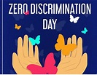

There is an urgent need to remove laws which harm people’s rights and to bring in laws which uphold the rights of every person. The path that ends AIDS is a rights path.

The recent, well-coordinated and well-funded global pushback against women’s rights, against the human rights of LGBTQ people, against sexual and reproductive health and rights, against democracy and against civic space is not only a threat to everyone’s freedom, it is a threat to everyone’s health.

In response to this threat, the AIDS movement and allies are “pushing back against the pushback, reminding world leaders of their commitments to uphold all human rights for all people. As communities across the world stand up for rights, the United Nations is not only on their side but by their side.

1 March this year is the tenth anniversary of Zero Discrimination Day. Upholding everyone’s rights is the responsibility of us all. Everyone can play a part in ending discrimination. On 1 March, and across the whole month of March, events, activities and messages will remind the world of this vital lesson and call to action: to protect everyone’s health, protect everyone’s rights.

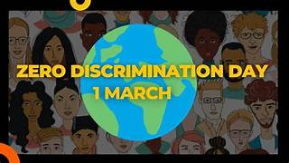

## Theme of Zero Discrimination Day 2024

**“To protect everyone’s health, protect everyone’s rights”,** the theme for Zero Discrimination Day 2024 emphasizes the critical link between health and human rights. Ensuring access to healthcare services without discrimination is paramount to achieving optimal health outcomes and upholding the rights and dignity of every individual.

## Ending Discrimination: A Global Imperative

**Combatting Criminalization**

UNAIDS underscores that criminalization perpetuates discrimination and structural inequalities, particularly in the context of public health issues like HIV/AIDS. Laws and policies that criminalize certain behaviors contribute to stigma and discrimination, hindering efforts to address health challenges effectively.